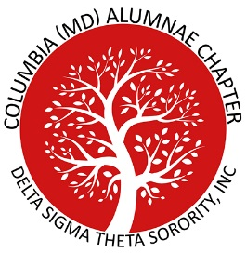
Columbia (MD) Alumnae Chapter
Delta Sigma Theta Sorority, Inc.

Scholarships and Awards
General Qualifications
- Must be an African American High School Senior Residing in Howard County and Attending a Howard County High School
- Must Plan to Enter College in 2022
- Must Have a GPA of At Least 2.5 on a 4.0 Scale
- Must Have Performed School and/or Community Service
- Must Have Demonstrated Leadership Abilities Specific to the Requirements of the Scholarship or Award for Which You Are Applying
Application Deadline is February 28, 2022.
Interested students and their parents or guardian may request an application by email at scholarship@columbiamddst.org

(Note: If your Mother is a member of Delta Sigma Theta Sorority, Incorporated, you are not eligible to receive this scholarship or award.)
If you have questions related to scholarships or awards, please contact us at:
Columbia (MD) Alumnae Chapter
Scholarship Committee
P.O. Box 2395 Columbia, MD 21045 ▲ (410) 730-9553
scholarship@columbiamddst.org

